Revised September 17, 2013

NSLC Agency Stores – Beer Voucher Process

The process for receiving reimbursement for Brewery beer vouchers and Labatt cheques that are accepted as tender at NSLC Agency store locations:

Agency Stores will be required to submit a completed Beer Voucher package that must contain the following to be reimbursed for Redeemed Beer Vouchers:
- Redeemed beer vouchers and Labatt cheques including the copies of the cash register receipts sorted by Brewery
- Completed Beer Voucher spreadsheet totaled by Brewery

Packages which do not contain the above will be returned to the Agent.

Requirements:

- The agent will need to provide all redeemed beer vouchers and Labatt cheques along with a copy of the cash register receipt upon which the beer voucher and Labatt cheque was accepted as tender.
- On the receipt the agent must indicate which product and the value of the product for which the beer voucher was redeemed.
- The beer voucher must be defaced by marking ‘VOID’ on the face of the voucher.
- Labatt cheques are not to be defaced (voided) as the NSLC will be depositing the cheque.

Labatt cheque sample
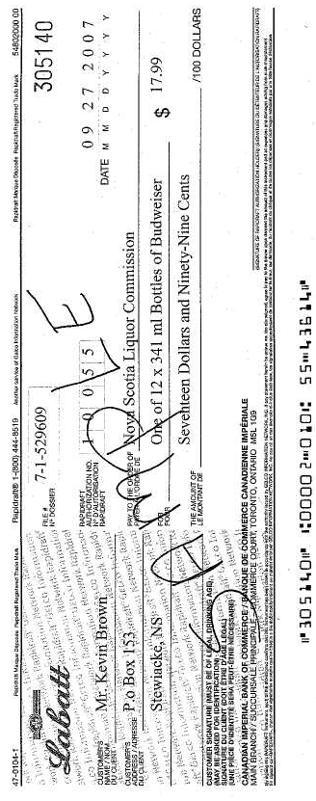

- The vouchers and Labatt cheques must be sorted and subtotaled by Brewery.
- A spreadsheet will be provided that should be completed each day beer vouchers and/or Labatt cheques are redeemed.
- The spreadsheet must contain the date and value of the vouchers and Labatt cheques redeemed by Brewery on that day.

Quarterly (June, September, December and March) or when the agent has accumulated $200 worth of beer vouchers and Labatt cheques the agent can forward the completed Beer Voucher package to:

NSLC Head Office
93 Chain Lake Drive
Halifax NS B3S 1A3
Attention: Rick Herritt

The beer vouchers will then be reviewed by NSLC and credit will be applied to the customers’ account. Reimbursement for outstanding credit balances are typically issued within 5 business days.

